


WorldWide Telescope: Sky Mode

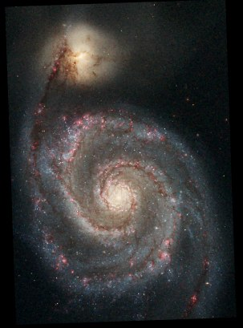 | 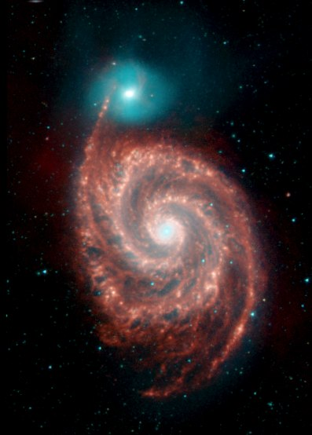
Optical image of M51, NASA, ESA, S. Beckwith (STScI), and the Hubble Heritage Team (STScI/AURA) | Infrared image of M51, NASA/JPL-Caltech/R. Kennicutt (Univ. of Arizona)

219th American Astronomical Society
Science Tools for Data-Intensive Astronomy:
A Standards-Based Approach to using Astronomical Data in the Classroom with Microsoft’s WorldWide Telescope

January 8, 2012

I. Introduction
Sky maps out various constellations, and the Imagery options demonstrate that there are many different wavelengths of light that can be recorded, in addition to the visible wavelength that we all see. Different wavelengths include x-ray, gamma, microwave, and so on. The most fascinating imagery is to most people the visible wavelength, but studies of the other wavelengths can reveal more specific information about what is happening, or has happened, to the stellar object.

Keyboard Shortcuts

Key Effect
Page Up (or -) Zoom out
Page Down (or +) Zoom in
Arrow Up Rotate up
Arrow Down Rotate down
Arrow Left Rotate left
Arrow Right Rotate right
Shift + zoom (Page Up/Down) Zoom slowly
Shift + pan (Arrow) Pan at a constant altitude
Esc Pause a tour
F5 Refresh the view
F11 Toggle between full screen and windowed mode
Shift + click To view Finder Scope

II. Background
- Study and Survey
WorldWide Telescope has the concept of a study and a survey:
- Study – is usually a single or composite image of one object in space.
- Survey – is usually a comprehensive collection of data from a large area of the sky.
A study is loaded from a “Collection” by clicking a thumbnail in the top panel.
A survey is selected from the “Imagery” list.
For default, the study is the “foreground” image and the survey is the “background” image.
There are options to reverse this, or to compare two studies or two surveys.
With the foreground and background image in view you are able to compare the two images with the “Image Crossfade” slider.

The View Menu has options to change what lines are drawn, and their colors. In this activity we will be focusing on the “Figures”, “Boundaries”, and “Focused Only” options.
- Figures – indicates that constellations figures should be rendered, the default color is red.
- Boundaries – indicates the boundaries of the constellation, the default color is blue.
- Focused Only – indicates the constellation in focus, the default color is yellow. The constellation in focus will display in a thumbnail at the bottom of the window.
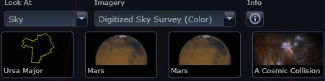
Example of Figures and Focused Only options:
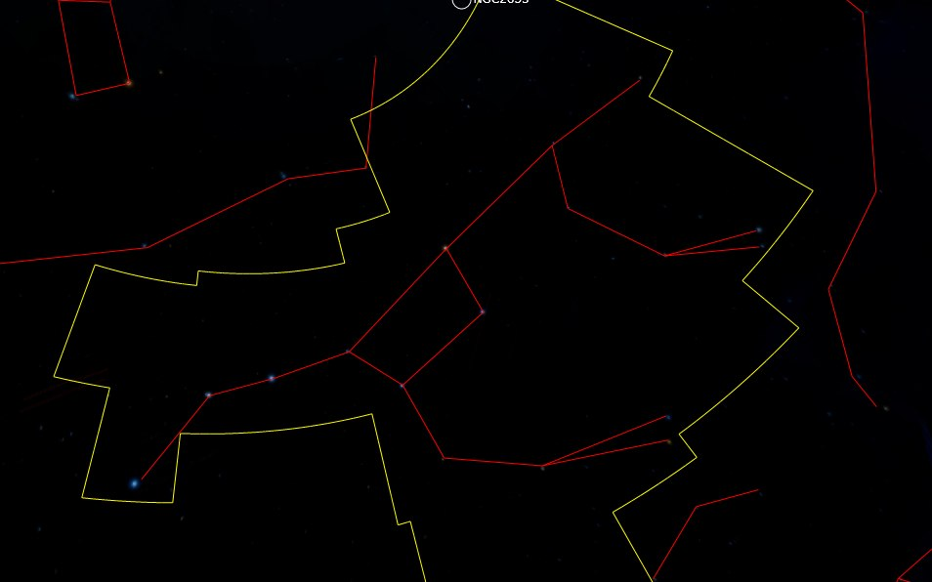
This is the Ursa Major constellation seen in red and the boundary of the constellation is shown in yellow

- Skyball
The skyball is located in the pane to the far right. The skyball displays the field of view relative to the celestial sphere and the selected constellation. The pane also shows the parameters of the view, i.e. the right ascension, declination, and field of view in degrees. The maximum field of view angle is 60:00:00 degrees.

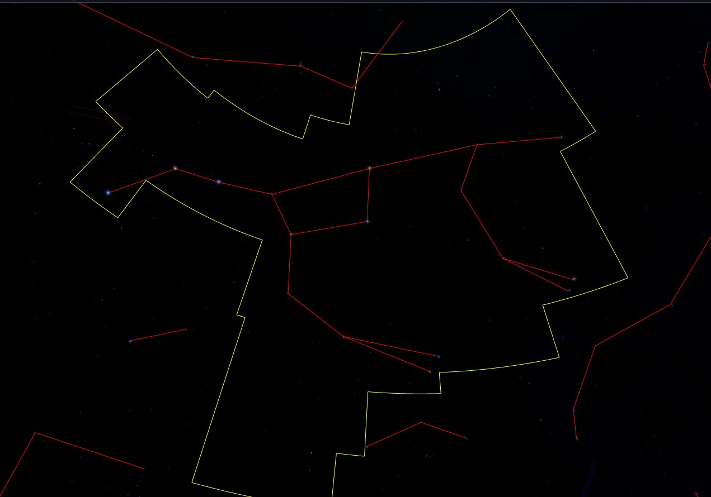
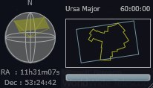
The constellation Ursa Major (top) and the corresponding skyball view (bottom).

III. Image Cross-fade: Part 1

- Open the WWT Windows Client on your desktop.
- Make sure the “Sky” mode is selected in the “Look At” and the “Digitized Sky Survey (Color)” (DSS) is selected in the “Imagery” list.

- Click on “View” at the top of the browser/window.
- In the far left-hand box select “Figures”, “Boundaries”, and “Focused Only”. 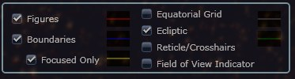
- In the third box from the left, click on the “Setup” button.
- Change the “Data Set” and “Region” to our current country, state, and city, (i.e. US cities, TX, and Austin).
- Then click on “OK”.
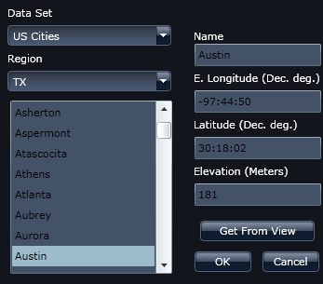
- Now click on the “Explore” tab.
- Search for “Chandra Studies”.
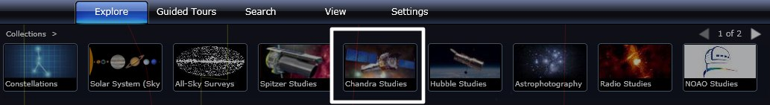
- Scroll through the thumbnails using the up arrow key to find the “Kepler’s Supernova”.
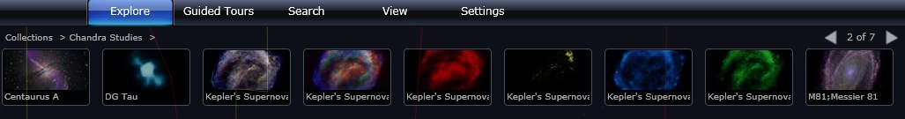
- Open the Finder Scope to determine the wavelength and color of the thumbnails image below.
Image | Wavelength | Color | Observation
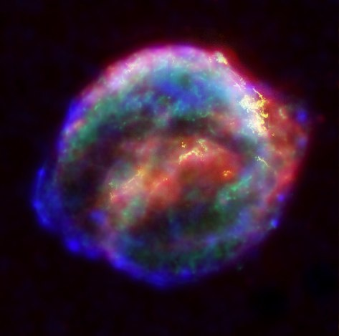 | Low and high energy X-ray, IR, optical | Blue, red, green, and yellow | The red appears to be along the edges
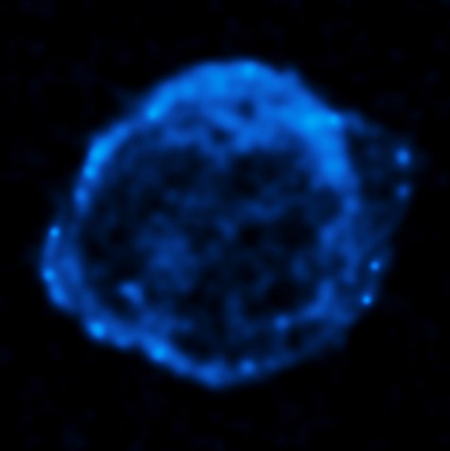
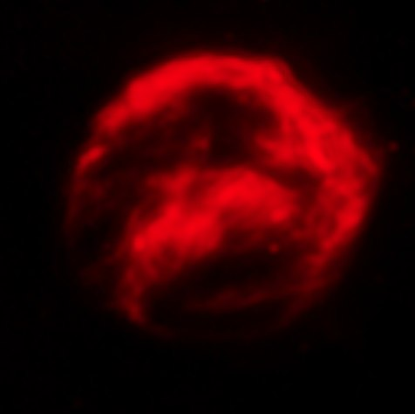
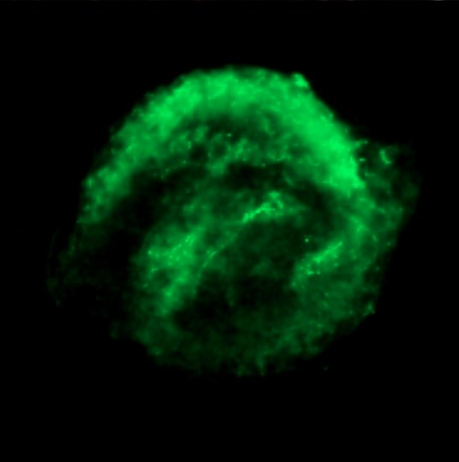
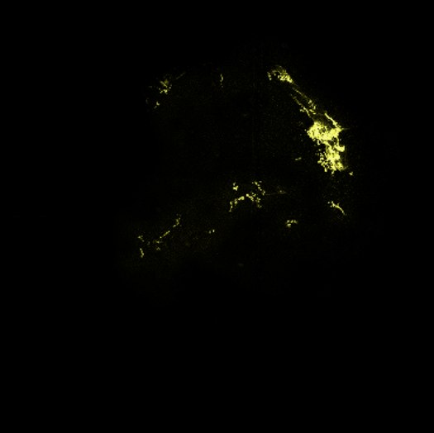
Bonus question: Which constellation is Kepler’s Supernova Remnant located?
- Locate the “Image Crossfade” at the bottom of the window, next to the Info button. Begin to scroll the slider to crossfade between the image selected and the DSS in the background.
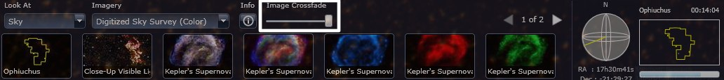

Additional information about Kepler’s Supernova:
- Composite image:
  - Blue, red, green, and yellow from the Chandra X-ray Observatory, Spitzer Space Telescope, and the Hubble Space Telescope.
  - “The combined image unveils a bubble-shaped shroud of gas and dust that is 14 light years wide and is expanding at 4 million miles per hour (2,000 kilometers per second). Observations from each telescope highlight distinct features of the supernova remnant, a fast-moving shell of iron-rich material from the exploded star, surrounded by an expanding shock wave that is sweeping up interstellar gas and dust.”
- Blue:
  - Higher energy X-ray from the Chandra X-ray Observatory.
  - Reveals the regions directly behind the shock front.
- Red:
  - Infrared image from the Spitzer Space Telescope.
  - Reveals microscopic dust particles that have been heated by the supernova shock wave.
- Green:
  - Lower-energy x-ray from the Chandra X-ray Observatory.
  - Reveals the location of the heated material expelled from the exploded star.
- Yellow:
  - Optical image from the Hubble Space Telescope.
  - Reveals where the supernova shock wave is slamming into the densest regions of the surrounding gas.
- Keplers’s Supernova Remnant is located about 13,000 light years away in the constellation Ophiuchus.
- Kepler’s Supernova Remnant: A Star’s Death Comes to Life http://chandra.harvard.edu/photo/2004/kepler/

IV. Image Cross-fade: Part 2
- Click on the “Search” tab and search for M51, also known as the Whirlpool Galaxy. Select the “Out of This Whirl” thumbnail.
- Identify the Hubble Space Telescope, the Chandra X-ray Observatory, and the Spitzer Space Telescope.
 | 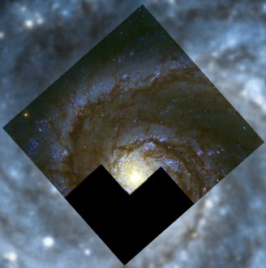 | 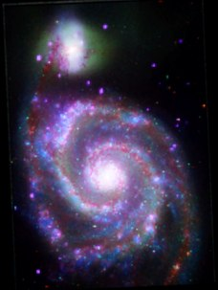 | 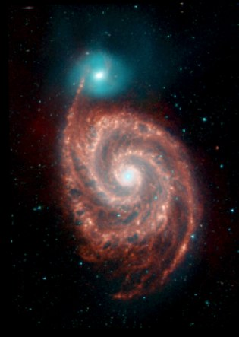 | 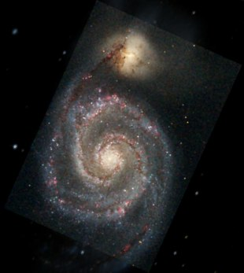
Telescope | ESA/Hubble
Observed wavelength | Optical

- Use the “Image Crossfade” and compare this image to the DSS in the background.
Choose the following images:
Hubble: Out of This Whirl: the Whirlpool Galaxy (M51) and Companion Galaxy
Chandra: A Classic Beauty; Messier M51; Whirlpool Galaxy; NGC 5194
Spitzer: M51; Whirlpool Galaxy; Messier 51; NGC 5194
 | Observations | Colors | Questions
Hubble (Whirpool  Galaxy Closeup) | Hubble resolution  is better than DSS image. | Brown in the spiral really stands out | What is the black patch in the image?
Chandra
Hubble
Spitzer

- At home: Search for M101/Pinwheel Galaxy! Have fun changing the background and foreground images. Search for images in different wavelengths and different telescopes.

Additional information about M51:
The visible-light HST image shows sweeping spiral arms, clusters of young stars, and clouds of molecular gas and dust. The X-ray Chandra image shows clouds of multi-million degree gas and point-like objects associated with black holes and neutron stars. The Spitzer infrared image in the longer infrared wavelengths track warm dust heated by recent star formation.

V. Scavenger Hunt

- Locate the View Menu along the top row.
- Change the Year, Month, and Date to January 8, 2012 and change the time to 12 Hrs 0 Min 0 Sec.
- Also change the Data Set option to “US Cities” and the Region option to “TX, Austin” and then click “Ok”. After you have made these changes what constellation is in the field of view?
- Locate the constellation Orion.
If you are having trouble locating it, use “Search” and type in “Orion”.
Hint: What time of day are you most likely to view this constellation?
Orion is the brightest constellation in the sky.

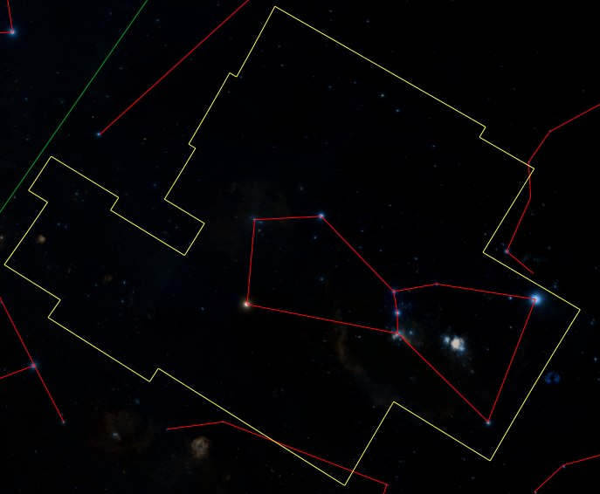
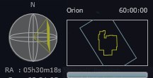
The constellation Orion (top) and the corresponding skyball view (bottom).

- Locate the following 10 objects in the sky. Record the right ascension (RA) and declination (DEC) of each object. Before you begin consider expanding your view to 60:00:00. Use the clues below.

Clue #1
Picture | Object Name | RA(H:M:S) and Dec (D:M:S)
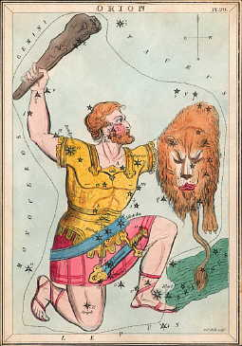 | Orion Nebula | 05:34:51, -05:26:39
 |  | 05:41:42, -01:51:23
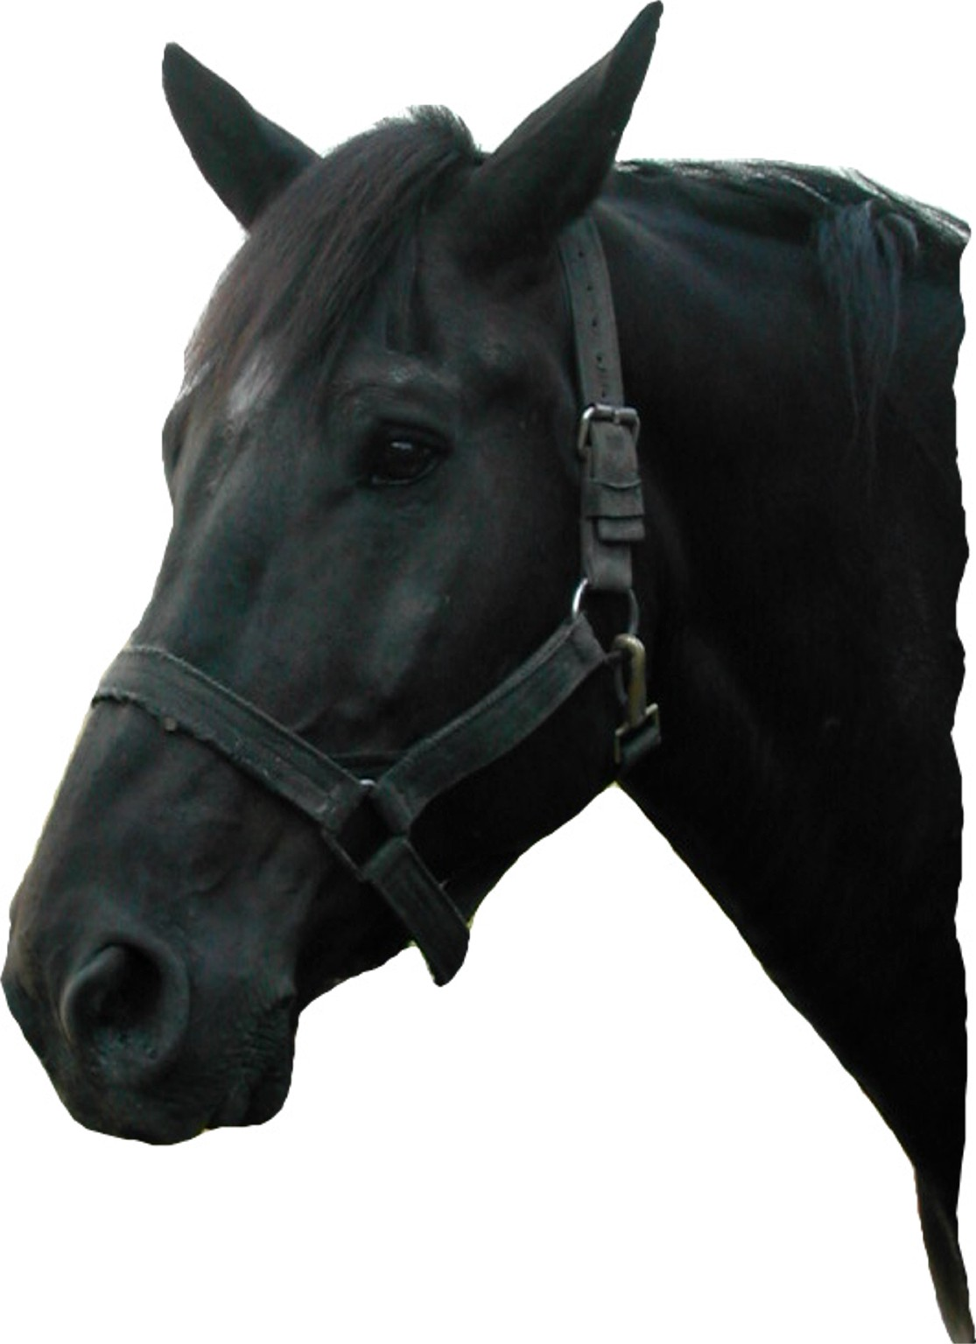 |  | 05:40:54, -02:28:00
 |  | 00:47:03, -11:52:20
 |  | 05:34:31, 22:01:02
 |  | 03:46:48, 24:08:22
 |  | 04:00:02, 36:35:45
 |  | 06:45:08, -16:42:58
 |  | 06:31:51, 04:57:26

- Record the distance of each object. Open the Finder Scope → Research → Information → Look up on Wikipedia. If Wikipedia is not available explore other Internet resources.

Clue #2: Record the distance of each object.
Words | Object Name | Distance  (in light years)
Closest region of massive star formation to Earth | Orion Nebula | 1,344 ± 20
Brightest star in the night sky
Easternmost star in the Belt of Orion
Farthest west on Orion’s Belt
Located in the constellation Perseus
Located in the Monoceros region of the Milky Way
Nearest star cluster to Earth
Planetary nebula in the constellation Cetus
Supernova remnant in the constellation Taurus
*Light-Year - The distance that a particle of light (photon) will travel in a year — about 10 trillion kilometers (6 trillion miles). It is a useful unit for measuring distances between stars.

VI. Answer key

Section III, Image Cross-fade: Part 1
- Question 11
Image | Wavelength | Color
 | Low and high energy X-ray, IR, optical | Blue, red, green, and yellow
 | Higher energy X-ray | Blue
 | Infrared | Red
 | Lower energy X-ray | Green
 | Optical | Yellow
Bonus question: Ophiuchus

Scavenger Hunt
- Question 3: What constellation is in the field of view? Answer: Cassiopeia
- Question 4: What time of day are you most likely to view this constellation? Answer: Look for Orion to be highest up around 10 p.m. in mid-January and 8 p.m. in mid-February.

- Question 5:
Picture | Object Name | RA and Dec
 | Orion Nebula | 05:34:51, -05:26:39
 | Flame Nebula | 05:41:42, -01:51:23
 | Horsehead Nebula | 05:40:54, -02:28:00
 | Skull Nebula (NGC 246) | 00:47:03, -11:52:20
 | Crab Nebula | 05:34:31, 22:01:02
 | The Pleiades | 03:46:48, 24:08:22
 | California Nebula | 04:00:02, 36:35:45
 | Sirius | 06:45:08, -16:42:58
 | Rosetta Nebula | 06:31:51, 04:57:26

- Question 6:
Words | Distance  (in light years) | Object Name
Closest region of massive star formation to Earth | Orion Nebula | 1,344 ± 20
Brightest star in the night sky | Sirius | 8.6 ± 0.04
Easternmost star in the Belt of Orion | Flame Nebula | 900 – 1,500
Farthest west on Orion’s Belt | Horsehead Nebula | 1,500
Located in the constellation Perseus | California Nebula | 1,000
Located in the Monoceros region of the Milky Way | Rosetta Nebula | 5,200
Nearest star cluster to Earth | The Pleiades | 391 – 456
Planetary nebula in the constellation Cetus | Skull Nebula (NGC 246) | 1,600
Supernova remnant in the constellation Taurus | Crab Nebula | 6,500

For more information on the Virtual Astronomical Observatory (VAO), visit:
www.virtualobservatory.org

For more WWT education resources, visit the WWT education page:
http://www.worldwidetelescope.org/ExperienceIt/ExperienceIt.aspx?Page=Educators

For more WWT Ambassadors education resources, visit the WWT Ambassadors page:
https://wwtambassadors.org

