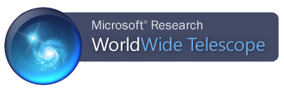


Imagery Data

Digitized Sky Survey (color) – default
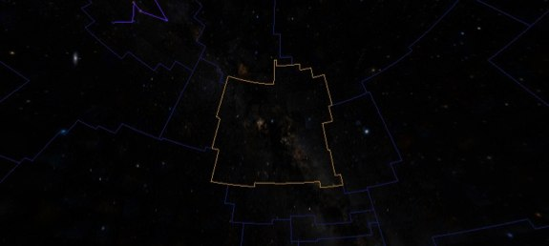
Type: Sky survey
Published: 1994
Created by: Space Telescope Science Institute (STScI) Catalogs and Surveys Group
Imaged by: Northern sky taken by the National Geographic Palomar Observatory in California and Southern sky taken by the UK Schmidt telescope in Australia
Observation period: Northern sky from 1948-1958 and the Southern sky from 1973 to 1988.
Wavelength observed: Visible

Hipparcos Catalog
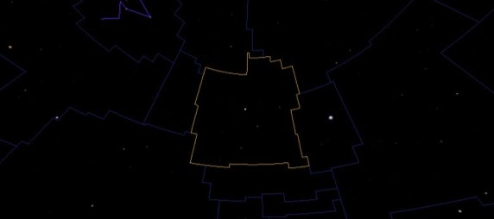
Name: Hipparcos is the name of a European Space Agency Mission and Satellite
Observation period: 1989 to 1993
Catalogued: 118,218 stars

VLSS: VLA Low-frequency Sky Survey (Radio)
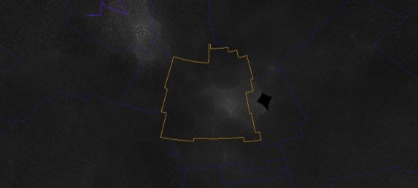
Type: Sky survey
Observation period: Ongoing
Survey contains: 358 overlapping images covering the entire sky north of the -30˚ declination
Identified: Over 70,000 sources of radio waves
Wavelength observed: Radio

Wilkinson Microwave Anisotropy Probe (WMAP) ILC 5-year Cosmic Microwave Background
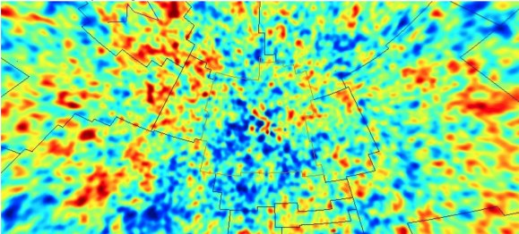
Type: All-sky survey
Observation period: 3 years, concluded in 2006
Wavelength observed: Microwave

SFD Dust Map (Infrared)
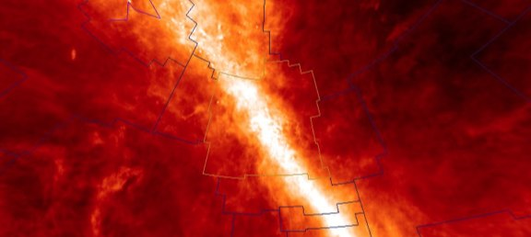
SFD: Schlegel, Finkbeiner, and Davis
Type: All-sky survey
Wavelength observed: Infrared

IRIS: Improved Reprocessing of IRAS
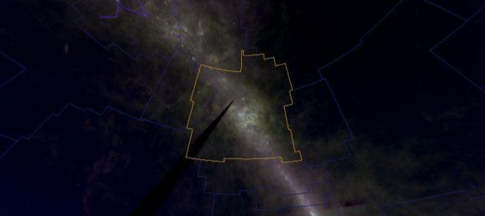
IRAS: Infrared Astronomical Satellite
Type: Sky survey (98% of the sky)
Started: 1983
Created by: Joint project of the US, UK, and the Netherlands
Wavelength observed: Infrared

2MASS: Catalog (Synthetic)
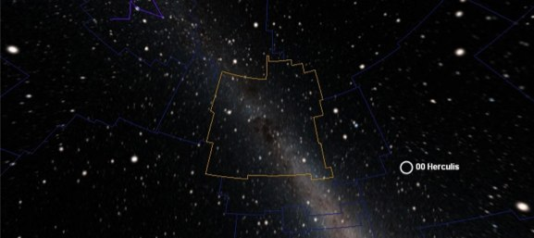
2MASS: Two Micron All Sky Survey
Catalogued: 470,992,970 sources
Created: 2MASS Point Source Catalog by the University of Massachusetts and the Infrared Processing and Analysis Center
Imaged by: Two 1.3-meter telescopes one at Mt. Hopkins, Arizona and one at Cerro Tololo Inter-American Observatory (CTIO), Chile
Begin: Northern facility in 19997 and the Southern facility in 1998
Wavelength observed: Infrared

Hydrogen Alpha Full Sky Map
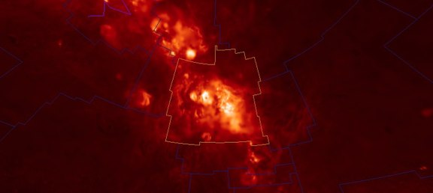
Type: All-sky survey
Generated by: Princeton University
Images by: Northern sky from Virginia Tech Spectral line Survey (VTSS) and the Southern H-Alpha Sky Survey Atlas (SHASSA). SHASSA images were taken by the CTIO in Chile.
Light observed: Red end of the visible

SDSS: Sloan Digital Sky Survey (optical)
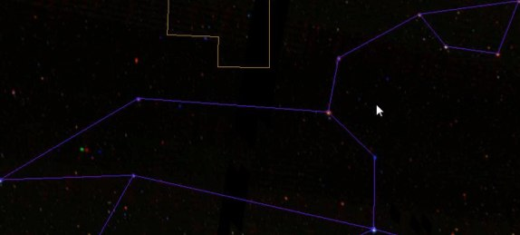
Type: Sky survey (more than a quarter of the sky)
Started: 2000
Observation period: Ongoing
Telescope: 2.4-meter at Apache Point Observatory, New Mexico
Catalogue: 3-dimensional maps containing more than 930,000 galaxies and 120,000 quasars

Tycho (Synthetic, optical)
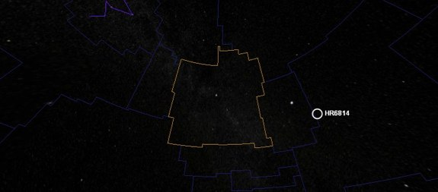
Data: 1991 European Space Agency’s Hipparcos satellite, Tycho 1 catalog, and over 140 other astrometric catalogs. Also the corrected data for the Tycho-1 stars.
Catalogue: 2,539,913 stars

USNOB: US Naval Observatory B 1.0 (Synthetic, optical)
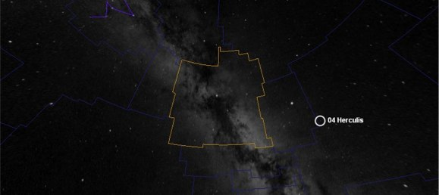
Catalogue: 1,042,618,261 objects
Data: 7,435 Schmidt plates
Observation by: Precision Measuring Machine (PMM) at the US Naval Observatory in Flagstaff, AZ.
Observation period: 50 years

GALEX (Ultraviolet)
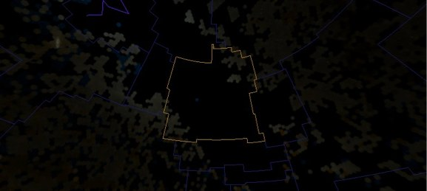
GALEX: Galaxy Evolution Explorer
Launched: 2003
Light observed: Ultraviolet
Sky coverage: 2/3
Imaged: Over half-billion objects

RASS: ROSAT All Sky Survey (X-ray)
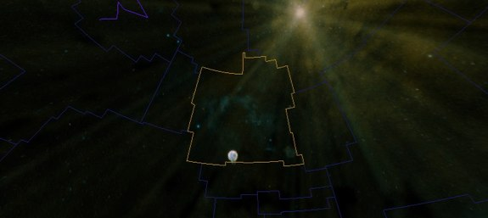
Released: March 2000
By: Max Planck Institut für extraterrestriche Physik
Type: All-sky survey
Light observed: X-ray
Catalogue: Faint source – 105,924 and the bright source – 18, 811

Fermi (Gamma)
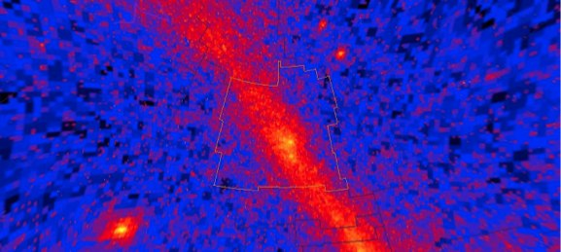
Launched: 2008
Telescope: Fermi Gamma-ray Space Telescope
Light observed: Gamma-ray

Black Sky Background

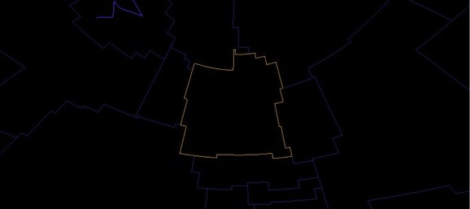
Sets the entire background black

For more information go to “Sky Surveys” section in the WorldWide Telescope User guide: http://www.worldwidetelescope.org/docs/worldwidetelescopeuserguide.html

For more information on the Virtual Astronomical Observatory (VAO), visit:
www.virtualobservatory.org

For more WWT education resources, visit the WWT education page:
http://www.worldwidetelescope.org/ExperienceIt/ExperienceIt.aspx?Page=Educators

For more WWT Ambassadors education resources, visit the WWT Ambassadors page:
https://wwtambassadors.org

