
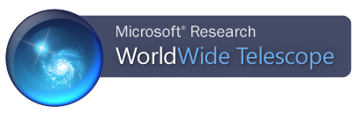

Exploration of the Solar System

I. Phases of the Moon – all about perspective.

In this section you will use WWT to explore how the moon appears to change phases from our vantage point on Earth over the course of a month.

Example Texas Essential Knowledge & Skills Standard (TEKS):
Observe and record data about lunar phases and use that information to model the Sun, Earth, and Moon system.

- Within WWT, be sure you have selected Look at Solar System, and Imagery is 3D Solar System View.
- Navigate to Earth by using the mouse to scroll and zoom or by clicking on the Earth image at the bottom of the screen.
- For this exercise, we want to see the position of the Sun, Earth, and Moon all at the same time. To make this easier, slide the “Planet Size” bar in the lower right to at least 50%.
- Zoom out from the Earth using the mouse scroll wheel until you can see the Sun, Earth, and Moon at the same time. Feel free to left-click and use the mouse to rotate your view if needed.
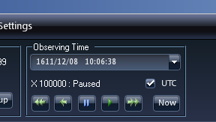
- We need to start with a common geometry. Click the “View” tab at the top of the screen. Click the fast-forward button four or five times in the “Observing Time” section. When the Earth is directly between the Sun and the Moon, hit pause.

- Imagine you are on Earth looking at the moon. Answer the following questions:
  - What side of the Earth must you be on to see the moon in this situation?
  - Given the position of the Sun, approximately what time of the day or night is it for you?
  - Does the moon appear bright or dark to you? Why? Again, remember that your perspective is of someone standing on the Earth’s surface looking up at the moon.
  - Using the chart below, what phase of the moon is this called?
- Fast forward the clock until the moon’s orbit takes it to be between the Earth and the Sun. Answer the following questions:
  - What side of the Earth must you be on to see the moon in this situation?
  - Given the position of the Sun, approximately what time of the day or night is it for you?
  - Does the moon appear bright or dark from your perspective on the Earth? Why?
  - Using the chart below, what phase of the moon is this called?
- Assuming the Earth is a clock with the Sun positioned at noon, fast forward until the moon is at the 9:00 position. Answer the following questions:
  - How does the moon look to you from this perspective if you are standing on the Earth? Why?
  - Using the chart below, what phase of the moon is this called?
- Based on your answers and experiences using WWT, would you say that the dark portions of the moon are caused by shadows? If so, what is causing the shadows? If not, why do we see some portions of the moon as dark?
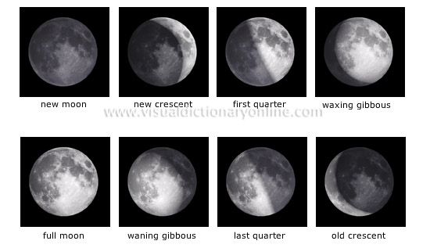
The lunar phases, as seen by an observer on the Earth.

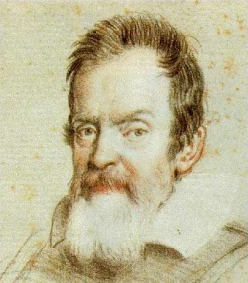
II. Overturning the Earth-centered Universe:
WWT as a Time Machine

For centuries, the belief was that the Universe was Earth-centered. This was easy to believe. When you look at the night sky you can see the stars apparently moving around the Earth over the course of the night. The invention of the telescope provided Galileo with the tools to explore the heavens in more detail. In this section, you will use the power of the WWT to go back in time and reproduce Galileo’s observations of Jupiter’s moons and overturn the long-held notion that everything must orbit around the Earth.

Example Texas Essential Knowledge & Skills Standard (TEKS):
Use astronomical technology such as telescopes, binoculars, sextants, computers, and software.

- Within WWT, be sure you have selected Look at Solar System, and Imagery is 3D Solar System View.
- Navigate to Earth by using the mouse to scroll and zoom or by clicking on the Earth image at the bottom of the screen.
- This is the Solar System today. We want the Solar System from Galileo’s time. Click “View” at the top.
- Under the box labeled “Observing Time,” you should see the current date and time. Click the drop-down arrow next to the date and time for more options.
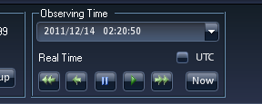

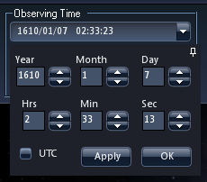
- Change the date to 1610, January 7th. Change the time to 4 hours. Click the UTC button. Click “Apply”. Click “Ok”. This is roughly the time of Galileo’s observations of Jupiter’s moons on January 7, 1610.

- Zoom to Jupiter by clicking the image of Jupiter at the bottom of the screen.
- You should see Jupiter and Jupiter’s four largest moons, now known as the Galilean moons because Galileo was the first to observe them. It might be necessary to increase the relative size of Jupiter by using the “Planet Size” bar in the lower right.
- In the “Observing Time” box, click the fast forward arrow four times until you are at 10,000 times the normal speed. Watch how the moons orbit around Jupiter and not the Earth.

Activity: You can have students attempt to draw the moon positions on consecutive nights to reproduce Galileo’s drawings, below:
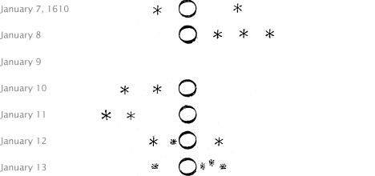

To do the drawings accurately, the student would need to be sure they are viewing Jupiter from Earth’s position. Follow the same steps as before, but after step #6, scroll outwards until you see both the Earth and Jupiter on the screen at the same time. Again, it helps to increase the sizes of the planets by using the “Planet Size” slider bar in the lower right.

Question to answer: Why would observations of the Galilean moons of Jupiter orbiting Jupiter be evidence against the Earth-centered model?

III. Earth’s Seasons

In this section, you will use a tour developed by the WorldWide Telescope Ambassador’s program at Harvard University to explore the causes of Earth’s seasons.

Example Texas Essential Knowledge & Skills Standards (TEKS):
Recognize that seasons are caused by the tilt of Earth’s axis.

Recognize that the angle of incidence of sunlight determines the concentration of solar energy received on Earth at a particular location.

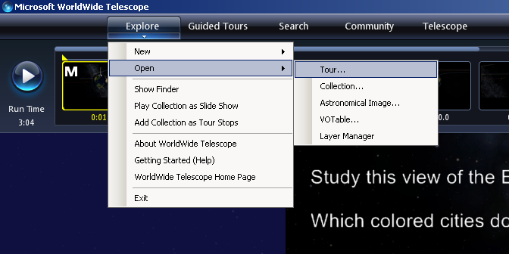
- To open the tour, click the bottom of the “Explore” tab at the top of the screen, and select “Open” then “Tour”.

- Select “Desktop” – “WWT Tours” – and then “03 Seasons”.
- In the upper left, click the play button.
- Follow the tour. Feel free to use this paper to write down answers to the questions.
HINT: While doing the tour, pay attention to the direction/tilt of Earth’s rotation axis in each of the examples. That will help you determine which hemisphere is receiving more or less direct sunlight.

For more information on the Virtual Astronomical Observatory (VAO), visit:
www.virtualobservatory.org

For more WWT education resources, visit the WWT education page:
http://www.worldwidetelescope.org/ExperienceIt/ExperienceIt.aspx?Page=Educators

For more WWT Ambassadors education resources, visit the WWT Ambassadors page:
https://wwtambassadors.org

