


Creating Tours in WorldWide Telescope

VAO Workshop, January 7, 2012

A First WWT Guided Tour
- Let’s jump right in and create a basic tour.
  - To begin, select “Sky” in the “Look At” menu and “Digital Sky Survey” as the “Imagery”. Click the down arrow below “View” and choose “Reset Camera”.
  - Click the “Guided Tours” tab in the Top Panel.
    - There will often be a pause while WWT loads tour info from its servers.

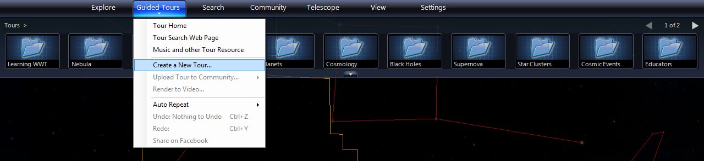

  - Click on the down arrow beneath the words “Guided Tours” and select “Create a New Tour …” from the dropdown menu.

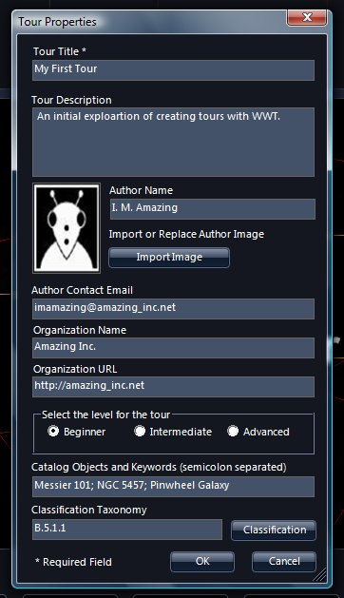

  - The Tour Properties window will appear. Fill in as much information as you want, but only the “Tour Title” is required. Click “OK” when finished.
- A new tab appears in the Top Panel labeled “My First Tour” or whatever you chose.

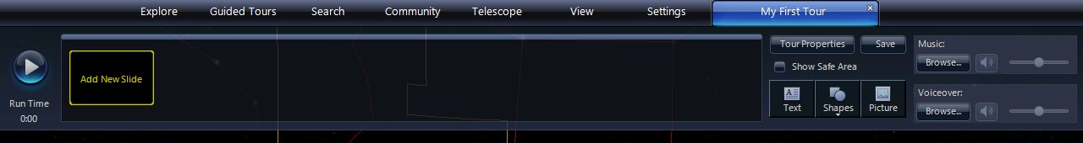

  - Click “Add New Slide” to create the first slide of the tour.

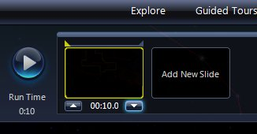

  - A slide appears on the left. The default time length of a slide is 10 seconds. Click on the time beneath the slide and two arrows appear. Click the down arrow to set the length to 5 seconds. Click the slide icon to set the time.
    - WARNING: After clicking the time, the arrow buttons sometimes appear and then disappear. Just click the time again. And again if needed. Annoying.

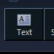

  - Click on the “Text” icon (middle of right side) to create a textbox.

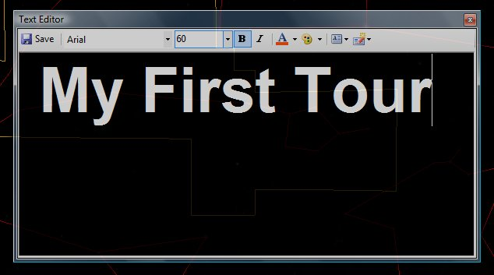

  - Enter the title of your tour. Make the font large (60) and bold (“B”). Click “Save” to add it to the slide.
  - Play the one slide tour by clicking the round blue play button on the left of the Top Panel. Not very exciting yet, but it’s a start.
  - Save the tour to disk by clicking the “Save” button (above and to the right of the “Text” button). Choose a suitable folder and filename (e.g., “my_first_tour.wtt”). Click “Save”.

- This tour will view the spiral galaxy Messier 101 (M101). To do so, one must leave the tour tab, navigate to the galaxy, and return to the tour tab.

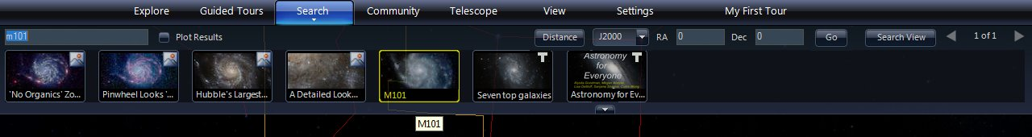

  - Click on the “Search” tab and enter “m101” in the search box. From the list of results, click on “M101” (highlighted in the image above). After WWT pans and zooms to M101, click on the tour tab.

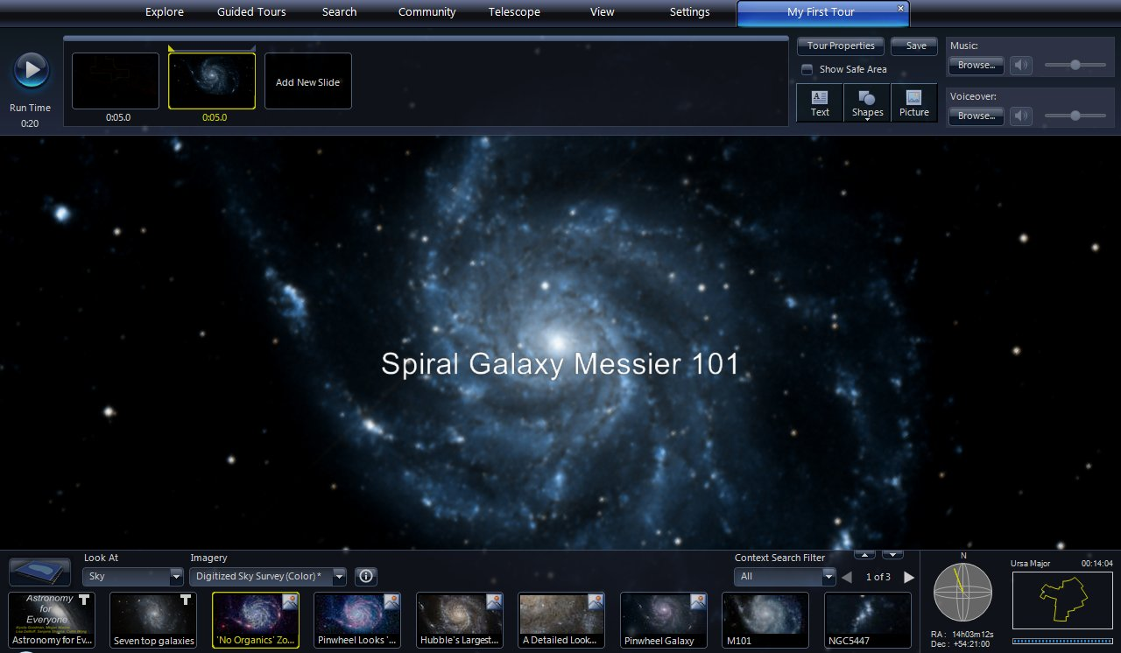

  - Click “Add New Slide” to create another slide. This slide will use the current M101 view in the View Panel.
    - Set the time to 5 seconds. WWT will automatically pan and zoom between slides. The 5 seconds starts after the pan and zoom completes.
    - Click the “Text” button and add the title “Spiral Galaxy Messier 101” in 40 point font.
  - Preview the tour by clicking the round blue play button on the left of the Top Panel. The main character has now been introduced.
  - Click the “Save” button.

- Explore a Hubble image of M101

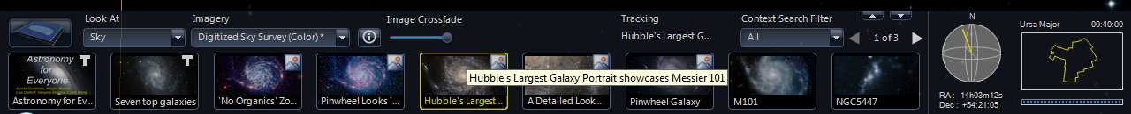

  - Look through the geographical highlights in the Lower Panel for the image labeled “Hubble’s Largest Galaxy Portrait showcases Messier 101”. Click on that image to bring it up in the View Panel.

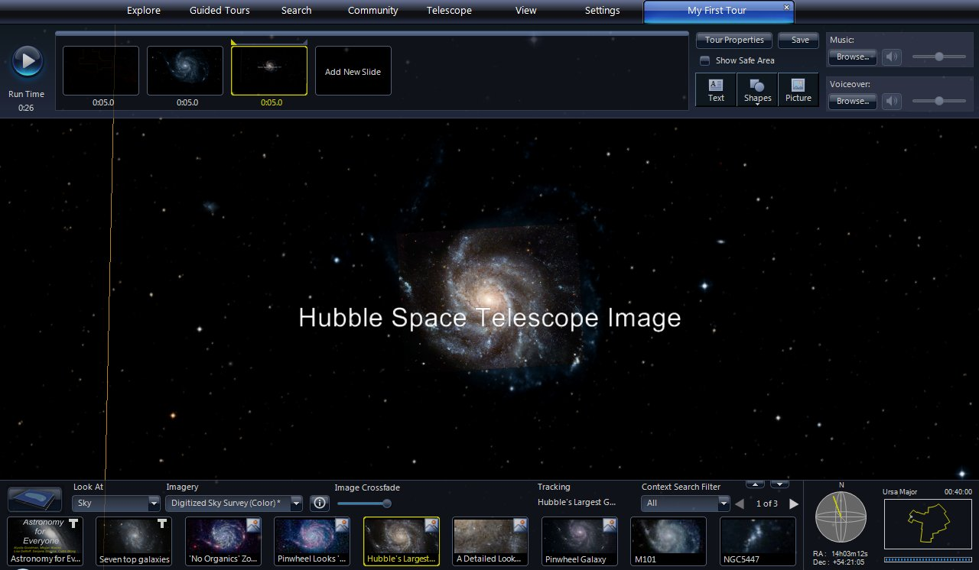

  - Click “Add New Slide”, set the time to 5 seconds.
    - Click the “Text” button and add the title “Hubble Space Telescope Image”.

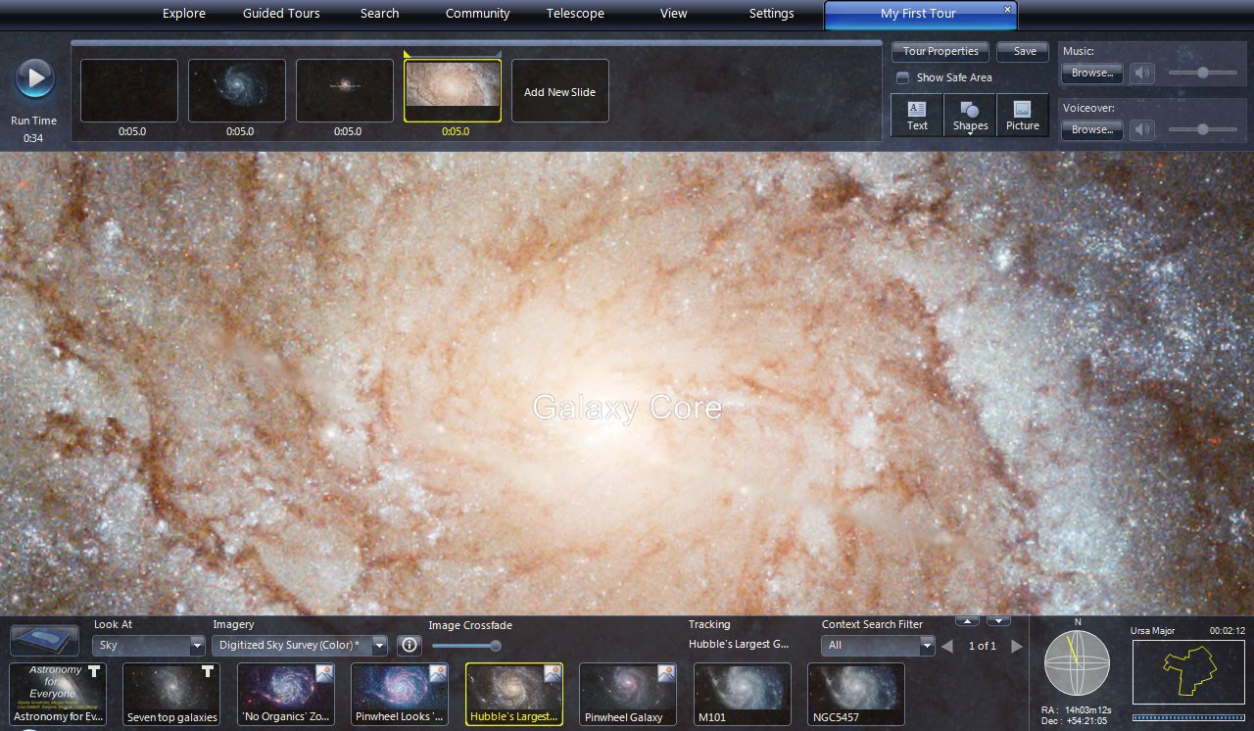

  - Zoom into the center of the Hubble M101 image until the FOV is about 2 arc minutes (FOV display will read 00:02:12).
    - Click “Add New Slide” and set the time to 5 seconds.
    - Click the “Text” button and add the title “Galaxy Core”

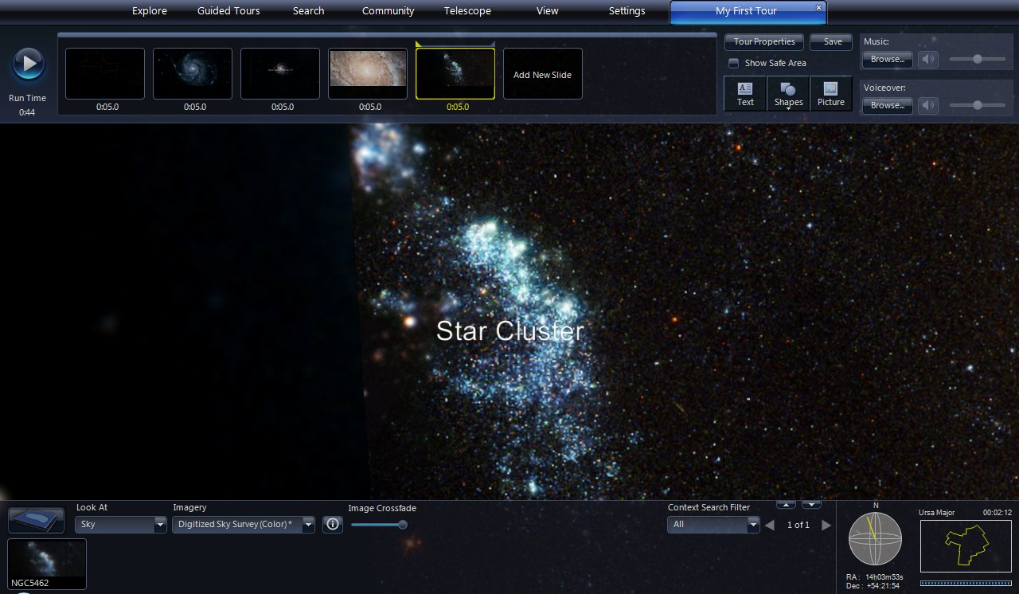

  - Pan to the left (toward 9 o’clock) across the galaxy to the outer edge of the spiral arms. Center on the star cluster shown in the image above.
    - Click “Add New Slide” and set the time to 5 seconds.
    - Click the “Text” button and add the title “Star Clusters”

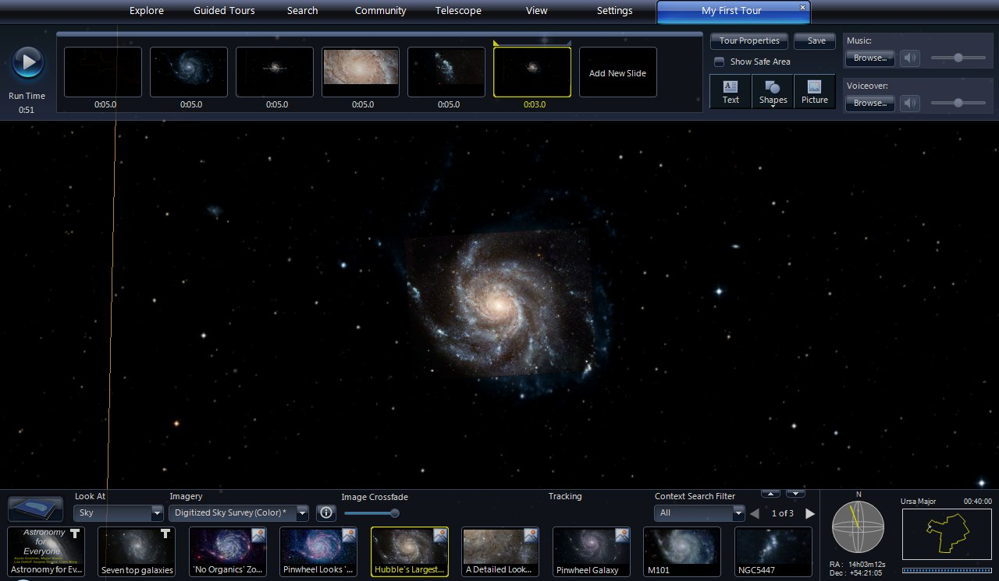

  - Zoom out until all of M101 is visible. Click again on the highlight image “Hubble’s Largest Galaxy Portrait showcases Messier 101” in the Lower Panel.
    - Click “Add New Slide” and set the time to 3 seconds.
  - Preview the tour by clicking the round blue play button on the left of the Top Panel. The story has basic character development, so it is time for a plot twist.
  - Click the “Save” button.

- Examine M101 in Infrared Light

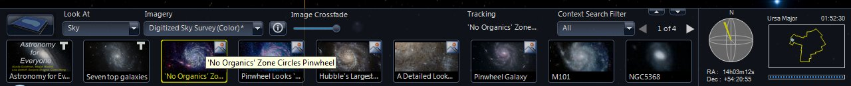

  - Find and click the highlight image labeled “No Organics Zone Circles Pinwheel”.

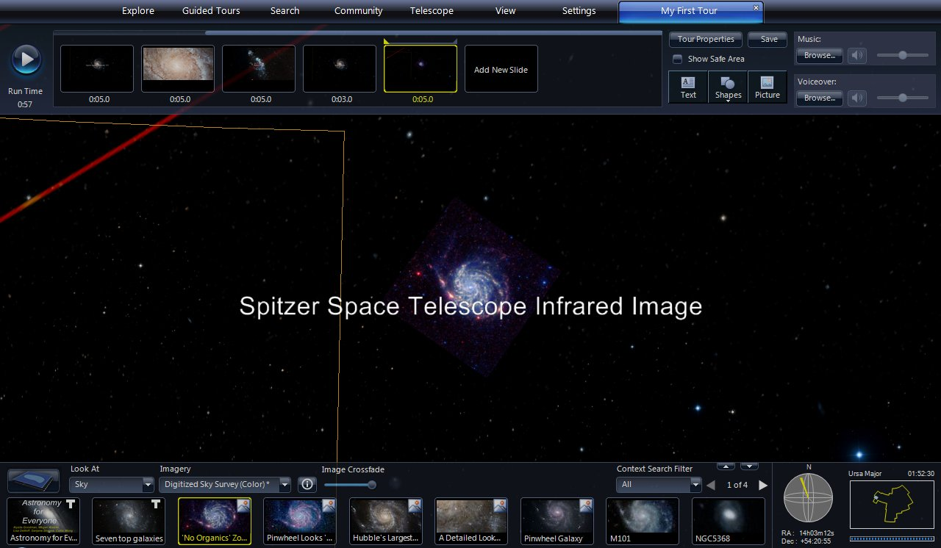

  - Click “Add New Slide” and set the time to 5 seconds.
    - Click the “Text” button and add the title “Spitzer Space Telescope Infrared Image”

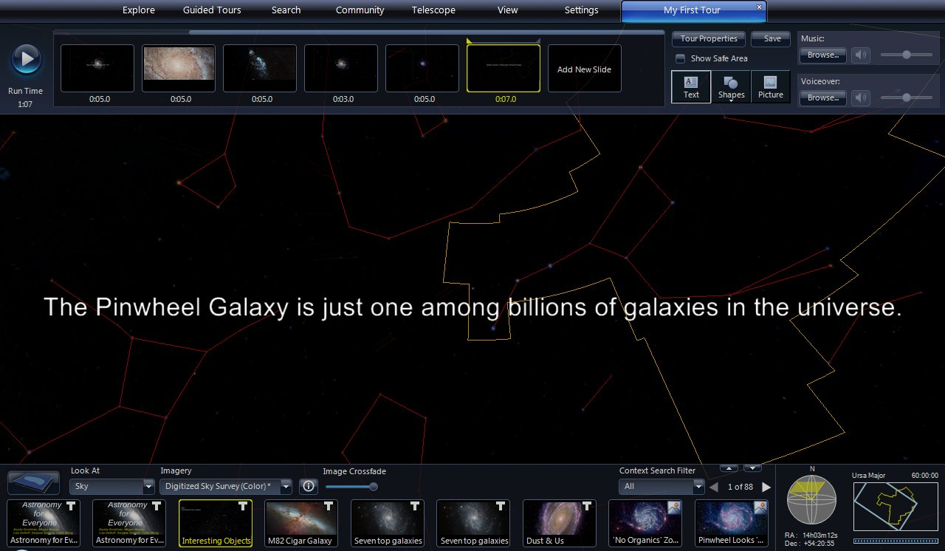

  - Zoom out to 60 degree FOV to finish off the tour
    - Click “Add New Slide” and set the time to 7 seconds.
    - Click the “Text” button and add the title “The Pinwheel Galaxy is just one among billions of galaxies in the universe.”
  - Preview the tour by clicking the round blue play button on the left of the Top Panel.
  - Click the “Save” button.
  - Congratulations! You have now joined the ranks of WWT tour creators.

Tips for Improving Tours – General

- Plan the tour in advance
  - The WWT tour creation tools do their job, but they are not as advanced as what is available in KeyNote or PowerPoint. Using other software to organize the tour ideas, gather images, write out the script, etc. will mean a smoother experience when creating the tour within WWT.
  - If you can’t afford commercial software, an excellent free presentation program is Impress - part of the LibreOffice suite ( http://www.libreoffice.org/ )

- Structure the tour to the strengths of WWT
  - Panning and zooming in WWT is relatively slow. Plan on somewhat lengthy transitions between objects in different parts of the sky. Quick cuts are not well-suited to the program
  - WWT has hundreds of images within the program. Peruse the collections and choose topics and themes that make use of the wide variety of images available.

- Edit tour properties last
  - When starting a new tour, the only item in Tour Properties that needs to be set is the Tour Title. Everything else can be left until later. Even the tour title can be changed later.

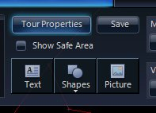

  - After the tour has taken shape, click the “Tour Properties” button (next to the “Save” button) and edit away.

Tips for Improving Tours – Slides

- Label each slide

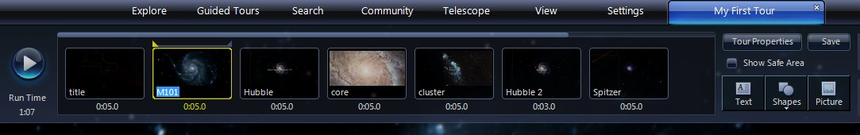

  - The icon for each slide has an area at the bottom for a text label. Click that area and enter a short label to help keep track of the slides.

- Keep slides “safe” for all computers
  - If working on a widescreen monitor, remember that someone viewing the tour on a standard monitor will not see the widescreen content.

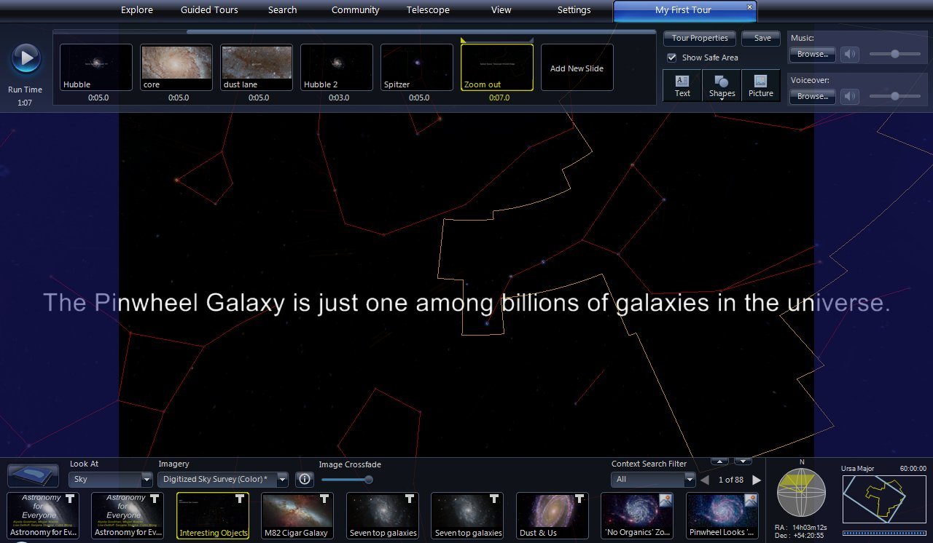

  - Click the “Show Safe Area” checkbox (above the “Text” button) and semi-transparent blue panels cover those parts of the screen that a standard monitor will not see. Keep the content of the tour within the safe area, and everyone will get the full experience.

- Refresh slide thumbnails
  - When WWT creates a new slide, it uses a current screenshot as the slide icon thumbnail image. When changes are made to the slide, that thumbnail is not automatically updated. For example, suppose the example tour was changed to visit a dust lane instead of the star clusters.

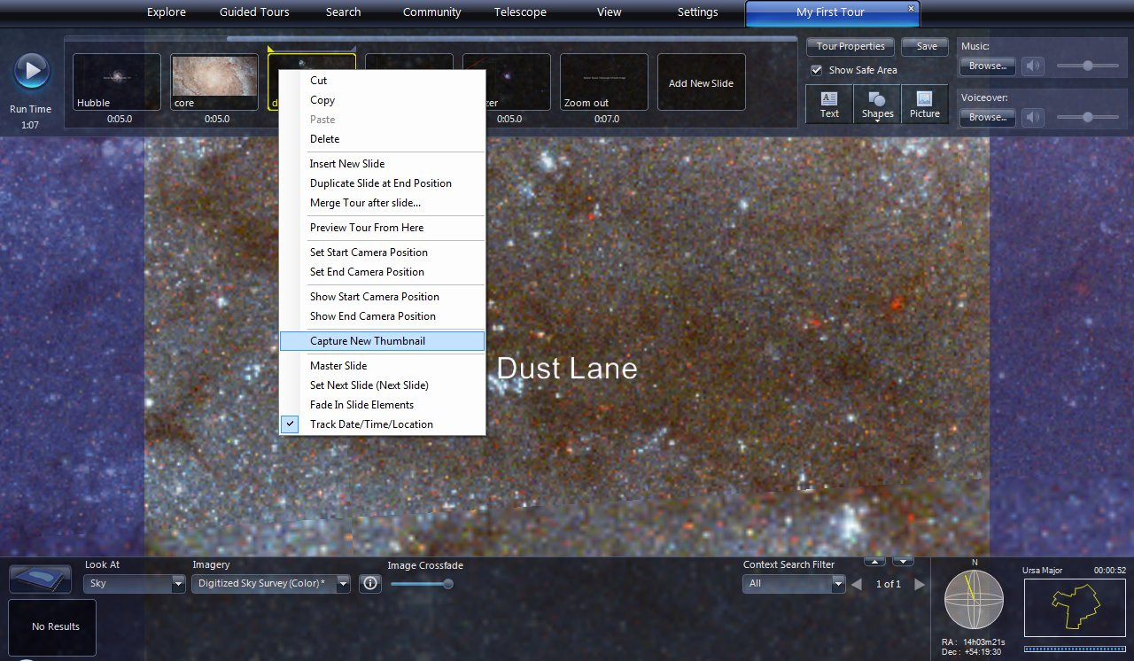

  - Right click on the slide icon and a dropdown menu appears. Select “Capture New Thumbnail” to get a current screenshot.

Tips for Improving Tours – Text

- Text adjustments
  - The textboxes in the example tour are used simply as titles and are left in the default central position. Of course, textboxes can do much more.

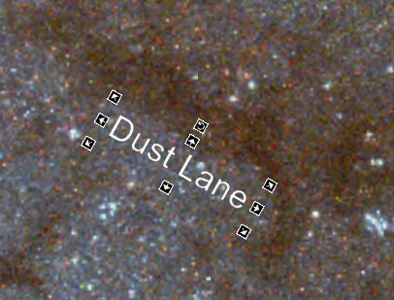

  - Click on the text in the View Panel and a series of controls appears. Click and drag the text to reposition it. Click any of the arrows to adjust the size. Click the top circular arrow to rotate the text.
  - If the tour has narration, audiences will appreciate onscreen text of the narration.

- Highlight text
  - In many cases, like the “Galaxy Core” slide in the example tour, text is difficult to read against a bright image.

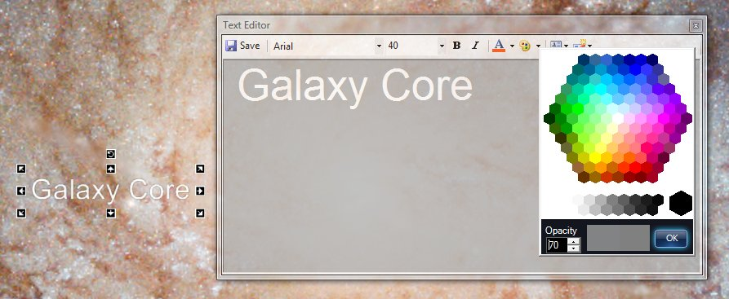

  - Double click the text to bring up the edit window. Click the palette icon to choose a background color for the textbox. A gray color with 70% opacity works well.

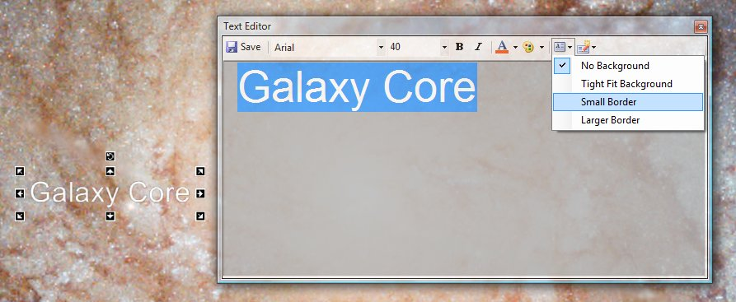

  - Set the background by clicking the background options menu (to the right of the palette). Choose an option for the size of the background. “Small Border” works well to separate text from the image underneath.

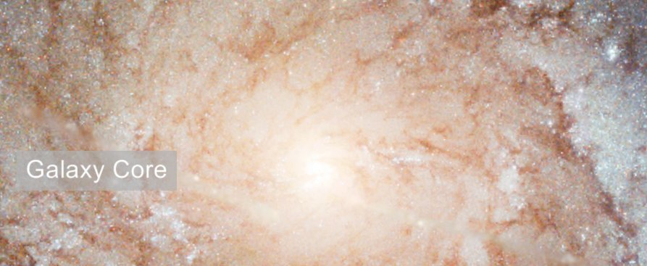

  - Here is the “Galaxy Core” text with a gray, 70% opacity, small border background.

